Application Deployment
(Deploy the given React application to a production ready state)

Application:
Clone the below mentioned repository and deploy the application (Run application in port 3000).
Repo URL : https://github.com/Vennilavan12/Brain-Tasks-App.git

1.Docker:
- Dockerize the application by creating Dockerfile
- Build an application and check output using docker image.
2.ECR:
- Create an AWS ECR repository for store docker images.
3.Kubernetes:
- Setup Kubernetes in AWS EKS and Confirm EKS cluster is running.
- Write deployment and service YAML files.
- Deploy using kubectl via Codedeploy.
4.CodeBuild:
- Create a CodeBuild project:
- Source: Connect to your repository
- Environment: Use managed image (Amazon Linux, Ubuntu)
- Write and define commands in buildspec.yml.

5.CodeDeploy:
- Create codedeploy application.
- create appspec.yml file to deploy applications in EKS.

6.Version Control:
- Push the codebase to a Git provider (GitHub).
- Use CLI commands to push code.

7.CodePipeline:
- Source: GitHub
- Build: AWS CodeBuild project
- Deploy: AWS CodeDeploy or deploy to EKS via Lambda or custom script.
8.Monitoring:
- Use CloudWatch Logs to track build, deploy, and application logs.
Submission Guidelines:
- GitHub Link: Submit full code repository.
- README File: Include setup instructions, pipeline explanation, and screenshots or create a document and attach all screenshots.
- Application deployed kubernetes Loadbalancer ARN.

Solution-1: - Docker:

Step-1:
Build Docker image and expose 80 port from container and 3000 port from Host.

Requirements:

1.AWS EC2 Instance with git and Docker installed
2.Clone the Given Repository
#cd /opt
#git clone https://github.com/Vennilavan12/Brain-Tasks-App.git
3.Write a Docker file to Build Docker image with apache2 webserver and copy required files from local to Docker container , build docker image and do the run and test URL http://localhost:3000

Docker File:

#cd /opt
#cd /op/ Vennilavan12/Brain-Tasks-App
#touch Dockerfile
#vim Dockerfile
## Use Ubuntu base image
FROM ubuntu:20.04

# Set environment variables to avoid interactive prompts
ENV DEBIAN_FRONTEND=noninteractive

# Update package list and install Apache
RUN apt-get update && \
apt-get install -y apache2 && \
apt-get clean && \
rm -rf /var/lib/apt/lists/*

# Copy HTML files to Apache document root
COPY ./dist/ /var/www/html/

# Set proper permissions
RUN chown -R www-data:www-data /var/www/html/

# Expose port 80
EXPOSE 80

# Start Apache in foreground mode
CMD ["apache2ctl", "-D", "FOREGROUND"]
4. Build Docker Image
#sudo docker build -t app01 .
5. Check Docker images is pulled to locally
#docker images

6.Run the container
#sudo docker run -d --name Webapp01 -p 3000:80 0d0882dc06ac
7.Test the URL
OUTPUT:
Docker Image Build is Done:
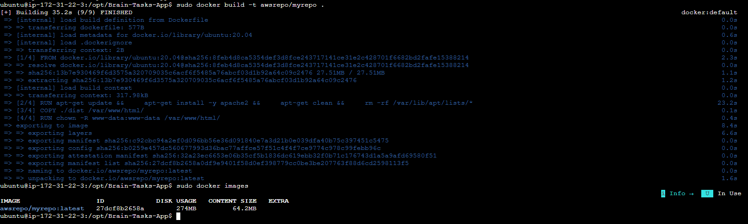
Launched container from New build images:
web site is able to access:
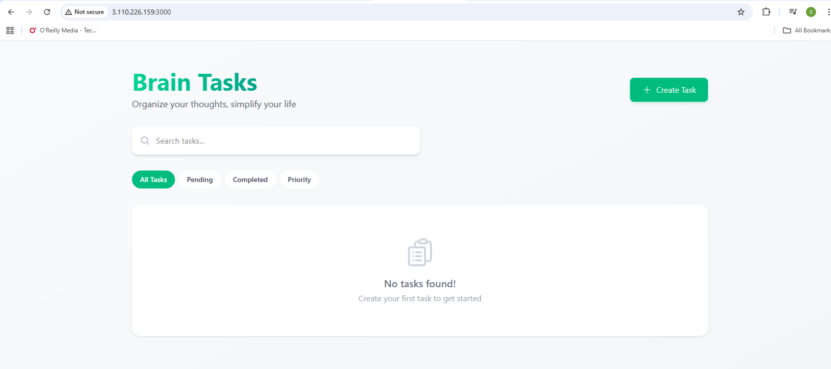
My Available Docker image from local server:
curl http://localhost:3000
Solution-2: - ECR:
Create an AWS ECR repository for store docker images.
AWS ECR repository Created:
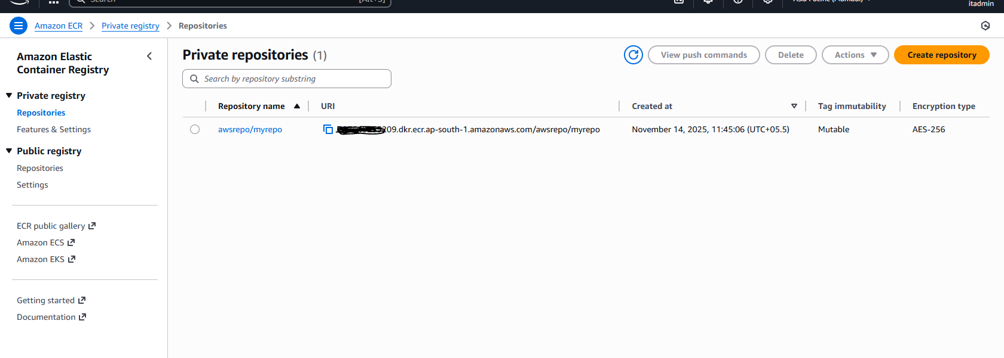
Pushed Docker images to ECR Public Repo:
1. Install AWS CLI
#install AWS cli in server

2.Configure aws access key and secrete key to puch images to AWS ECR
#aws configure
3.Attach AWS IAM policy AmazonEC2ContainerRegistryFullAccess and STS policy need to create
{
"Version": "2012-10-17",
"Statement": [
{
"Effect": "Allow",
"Action": [
"ecr:*",
"sts:GetCallerIdentity"
],
"Resource": "*"
}
]
}
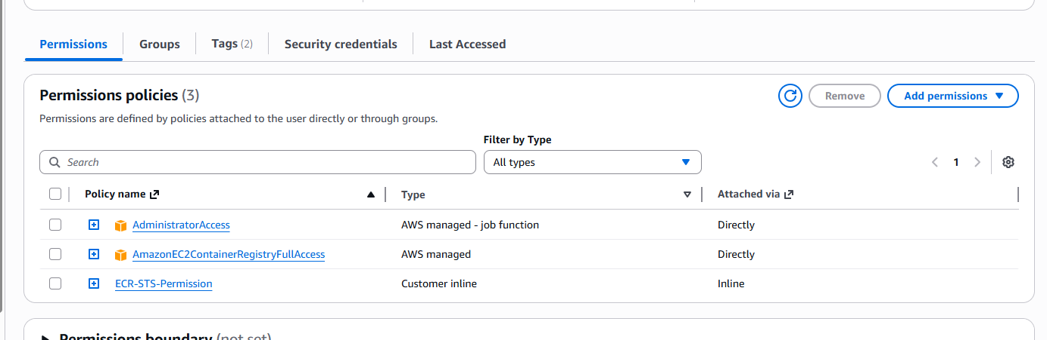
Pushed Docker Images to AWS ECR
1. Followed ECR Push comments and successfully pushed
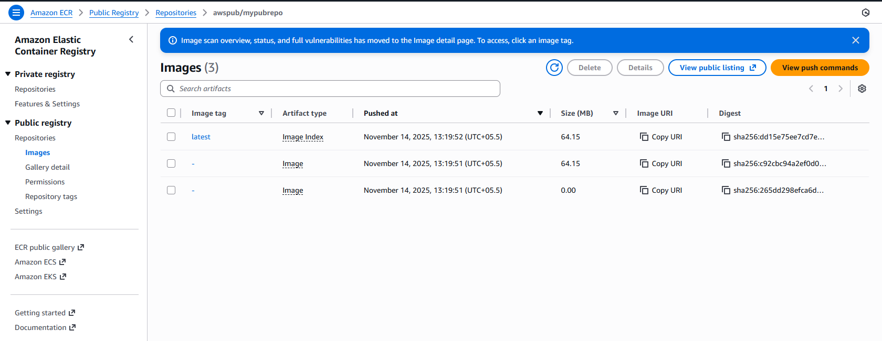
Solution-3: - Kubernetes AWS EKS::
Here's a complete example of Kubernetes Deployment and Service YAML files to deploy your Docker image from AWS ECR as a LoadBalancer service.
Make sure you have:
- kubectl configured with your Kubernetes cluster
https://kops.sigs.k8s.io/install/
install kubectl linux packages
aws eks update-kubeconfig --name srieksmasternode
- AWS ECR credentials configured in your cluster (usually via imagePullSecrets)
Create a Secret for ECR Authentication (if needed)
First, you might need to create a secret to pull images from ECR:
#kubectl create secret docker-registry ecr-registry-secret \
--docker-server=<your-aws-account-id>.dkr.ecr.<region>.amazonaws.com \
--docker-username=AWS \
--docker-password=$(aws ecr get-login-password --region <region>)
Complete Example with Placeholders Replaced
Here's a concrete example assuming:
- AWS Account ID: 123456789012
- Region: us-east-1
- Repository: my-app
- Tag: v1.0.0
- App runs on port 3000
TESTING AWS EKS CLUSTER:
#kubectl create deployment webapp01 --image=httpd:latest

#kubectl expose deployment webapp01 \
--port=3000 \
--target-port=80 \
--type=LoadBalancer
#kubectl get svc
#curl http://loadbalcerURL:3000
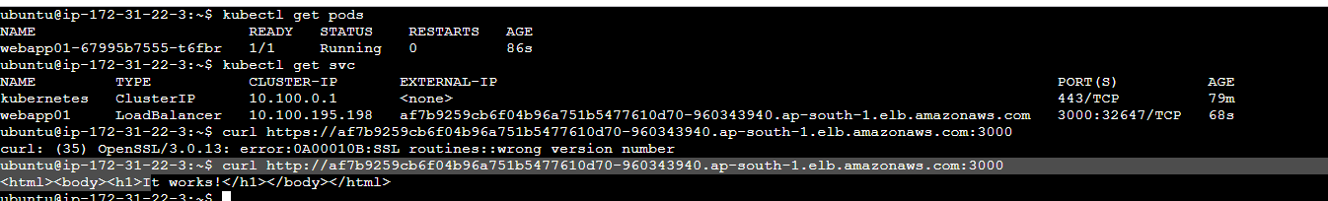
#kubectl get pods,svc
#curl http:loadbalcerURL:3000
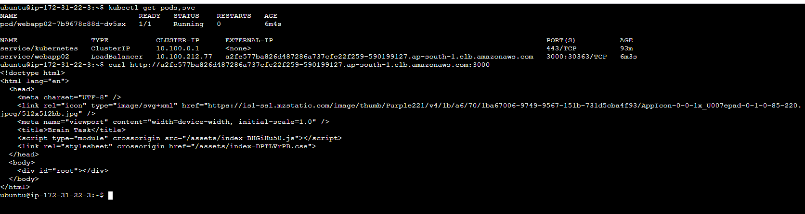
http://a2fe577ba826d487286a737cfe22f259-590199127.ap-south-1.elb.amazonaws.com:3000/
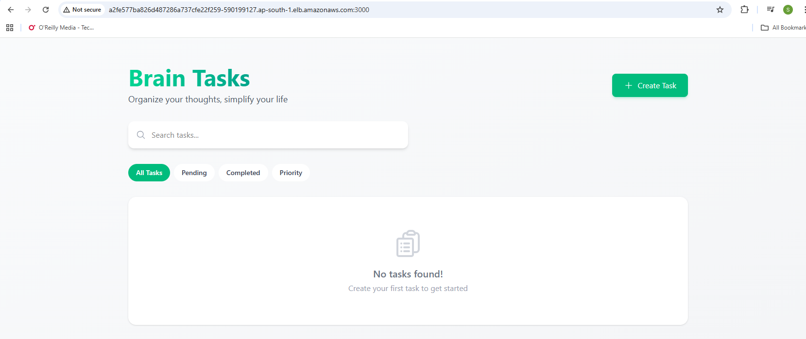
deployment.yaml:
apiVersion: apps/v1
kind: Deployment
metadata:
name: webapp02
spec:
replicas: 1
selector:
matchLabels:
app: webapp02
template:
metadata:
labels:
app: webapp02
spec:
containers:
- name: webapp02
image: public.ecr.aws/o2p4d1o6/awspub/mypubrepo:latest
ports:
- containerPort: 80 # change if your app listens on another port
service.yaml:
apiVersion: v1
kind: Service
metadata:
name: webapp02-service
spec:
type: LoadBalancer
selector:
app: webapp02
ports:
- protocol: TCP
port: 3000 # external port
targetPort: 80 # container port
Deployment Commands
# Apply the deployment and service
kubectl apply -f deployment.yaml
kubectl apply -f service.yaml

# Check the status
kubectl get deployments
kubectl get pods
kubectl get services

# Watch for the LoadBalancer EXTERNAL-IP
kubectl get service my-app-service -w
OUTPUT:
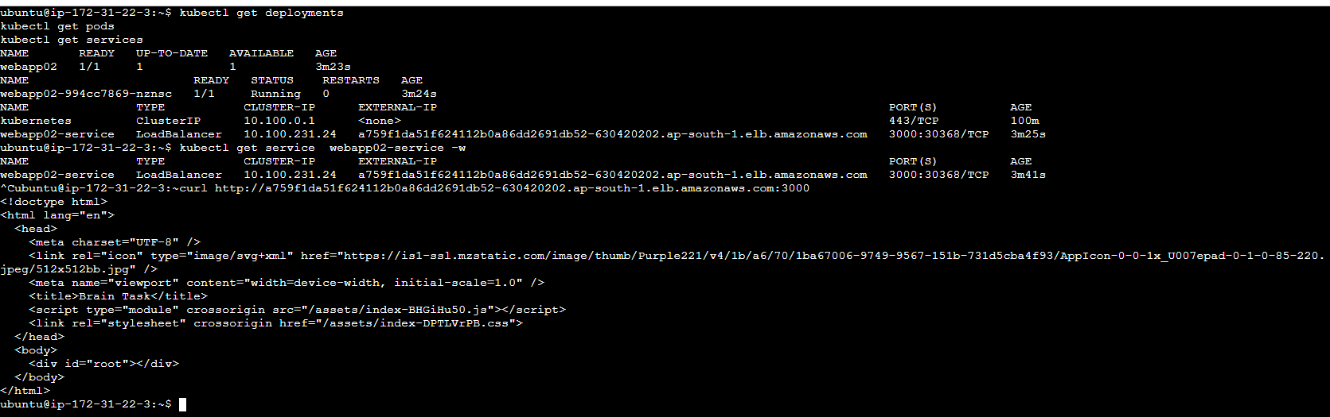
http://a759f1da51f624112b0a86dd2691db52-630420202.ap-south-1.elb.amazonaws.com:3000/
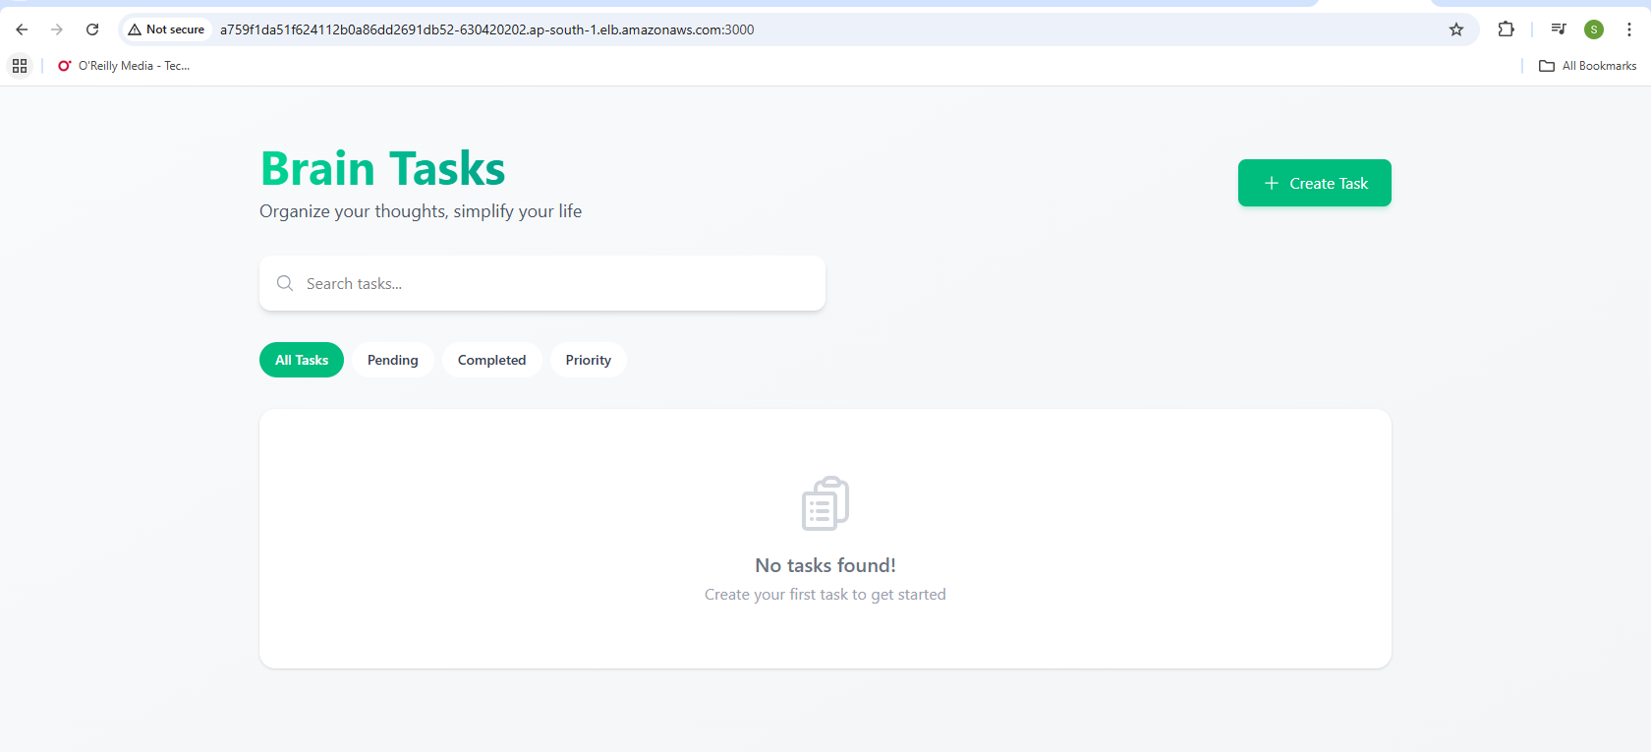
Solution-4: -
1,Create and test Code build first
CodeBuild:
Create Role for Code build to access EKS :

aws eks create-access-entry \
--cluster-name cicdk8masternode \
--principal-arn arn:aws:iam::757649255209:role/service-role/codebuild-build-project01-service-role \
--type STANDARD

aws eks associate-access-policy \
--cluster-name cicdk8masternode \
--principal-arn arn:aws:iam::757649255209:role/service-role/codebuild-build-project01-service-role \
--policy-arn arn:aws:eks::aws:cluster-access-policy/AmazonEKSClusterAdminPolicy \
--access-scope type=cluster
Version Control:
- Push the codebase to a Git provider (GitHub).
- Use CLI commands to push code.
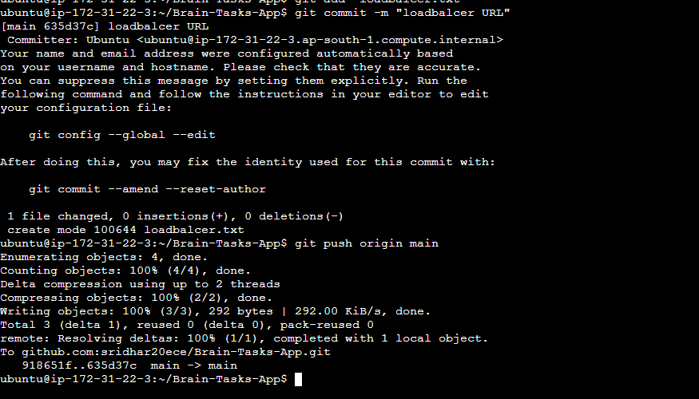
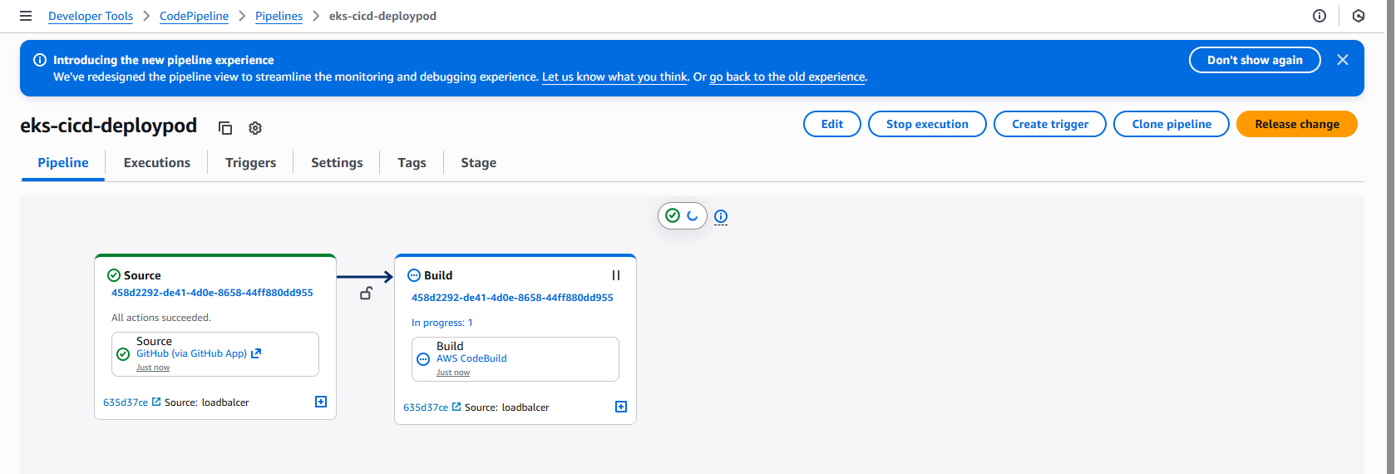
####Screen Shots####:-

1. ECR images Push
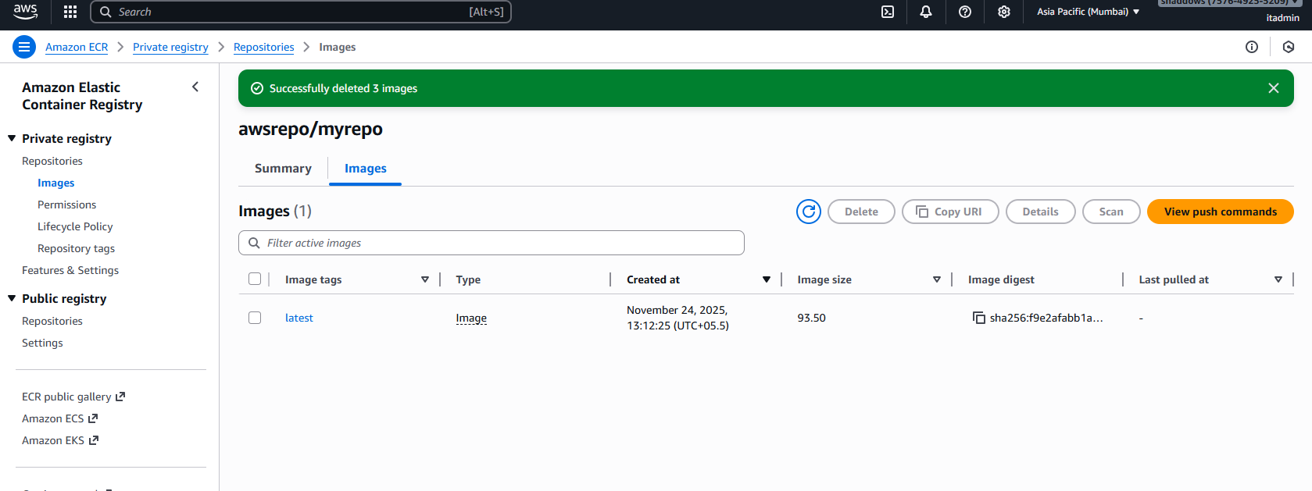
2. EKS nodes and service
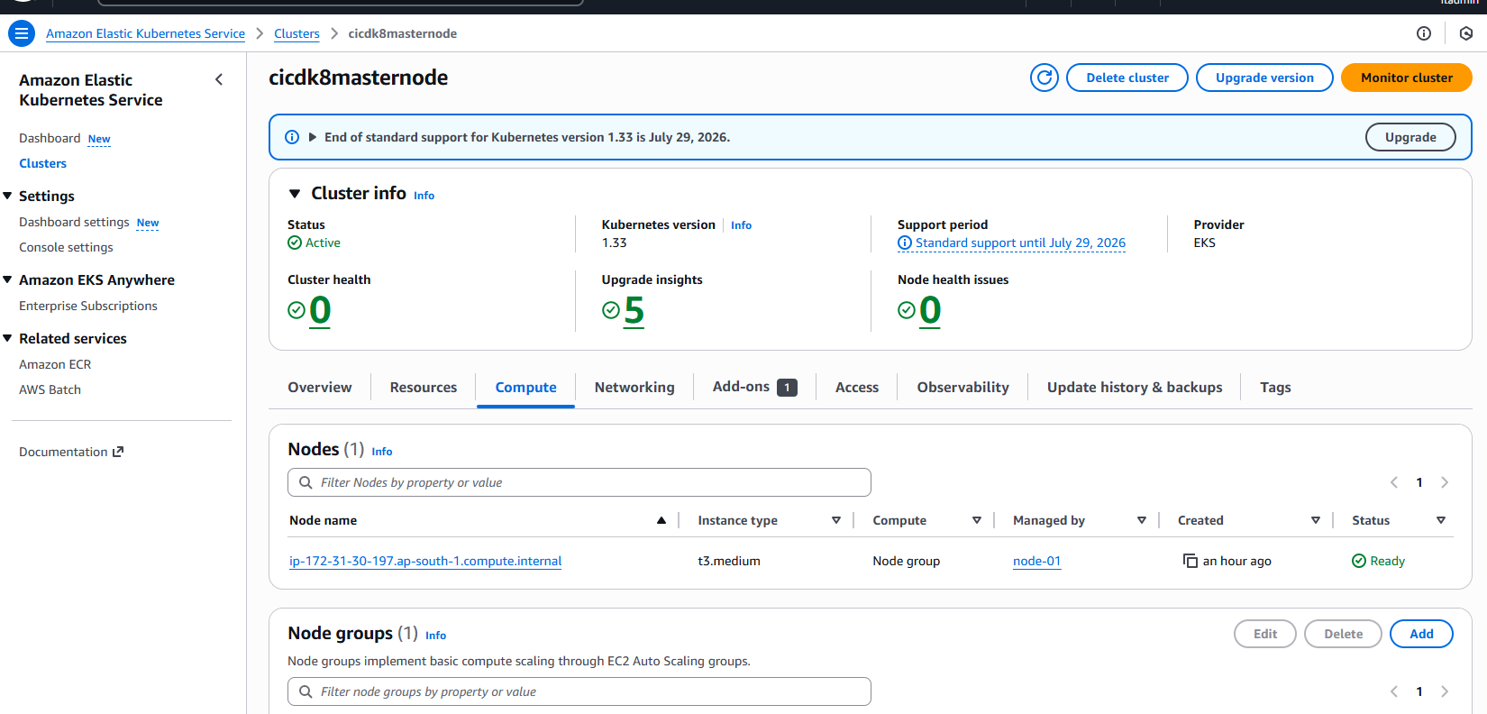
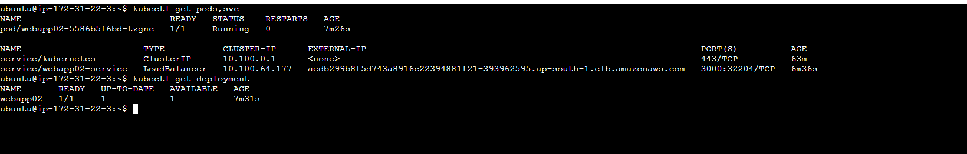
3. codepipeline success
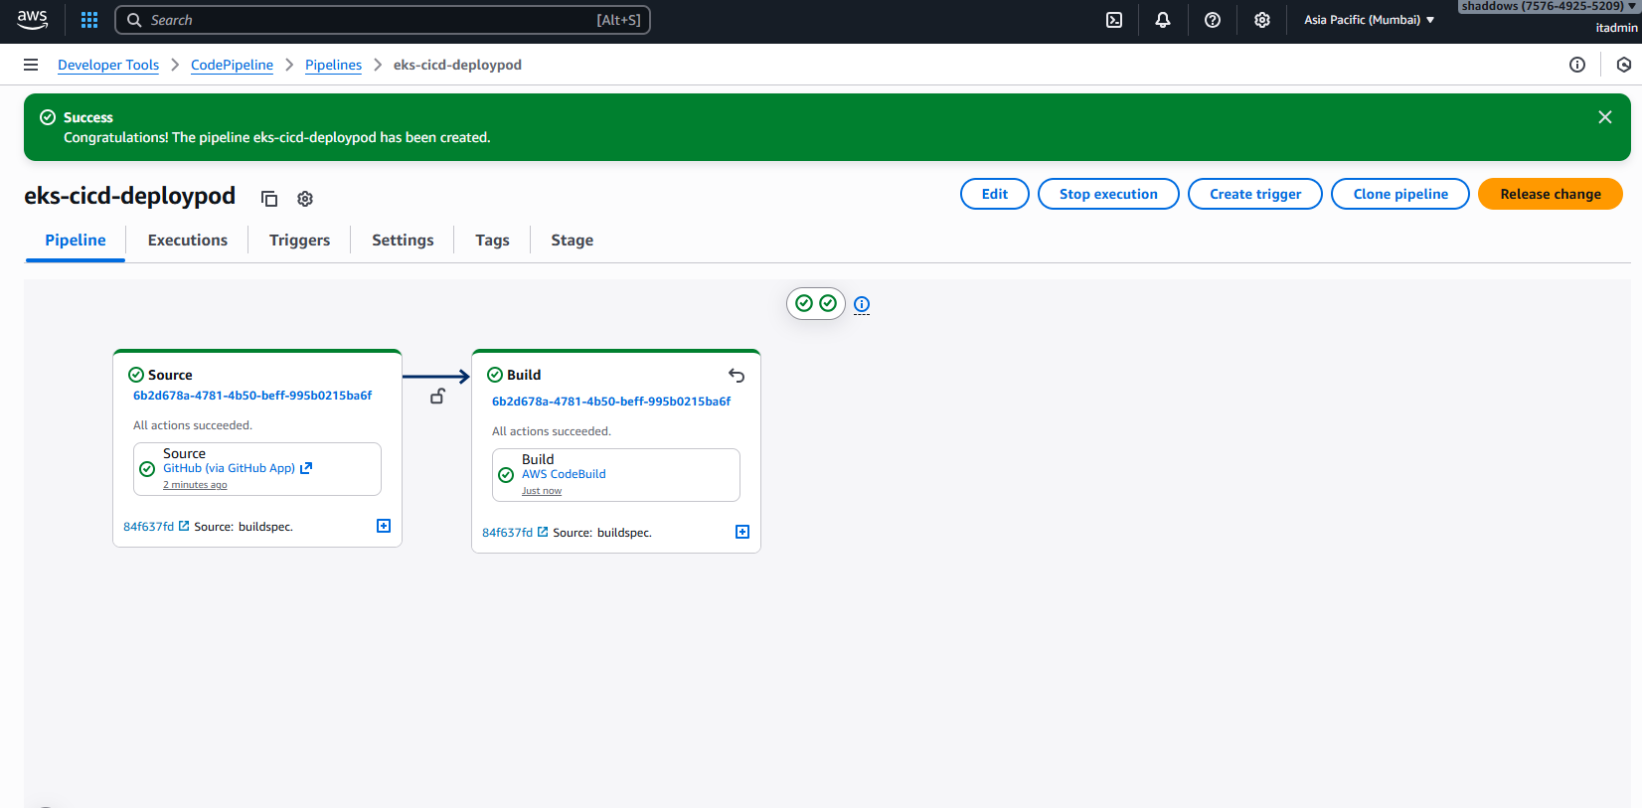
4.App running via LoadBalncer URL
http://aedb299b8f5d743a8916c22394881f21-393962595.ap-south-1.elb.amazonaws.com:3000/
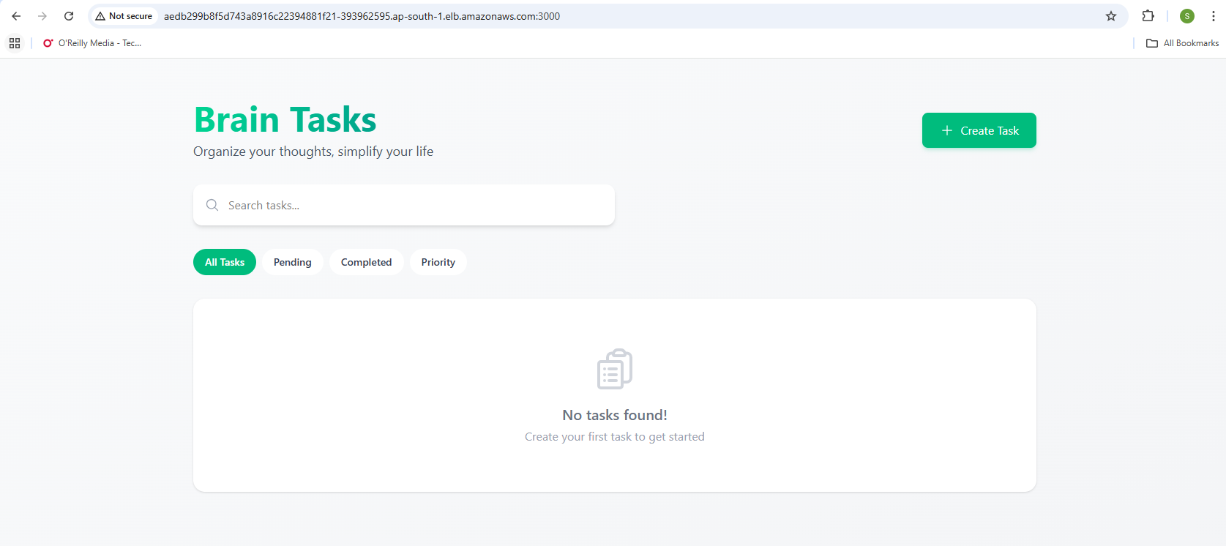
#Monitored:
1.CodeBuild Logs ==> Build Phase output
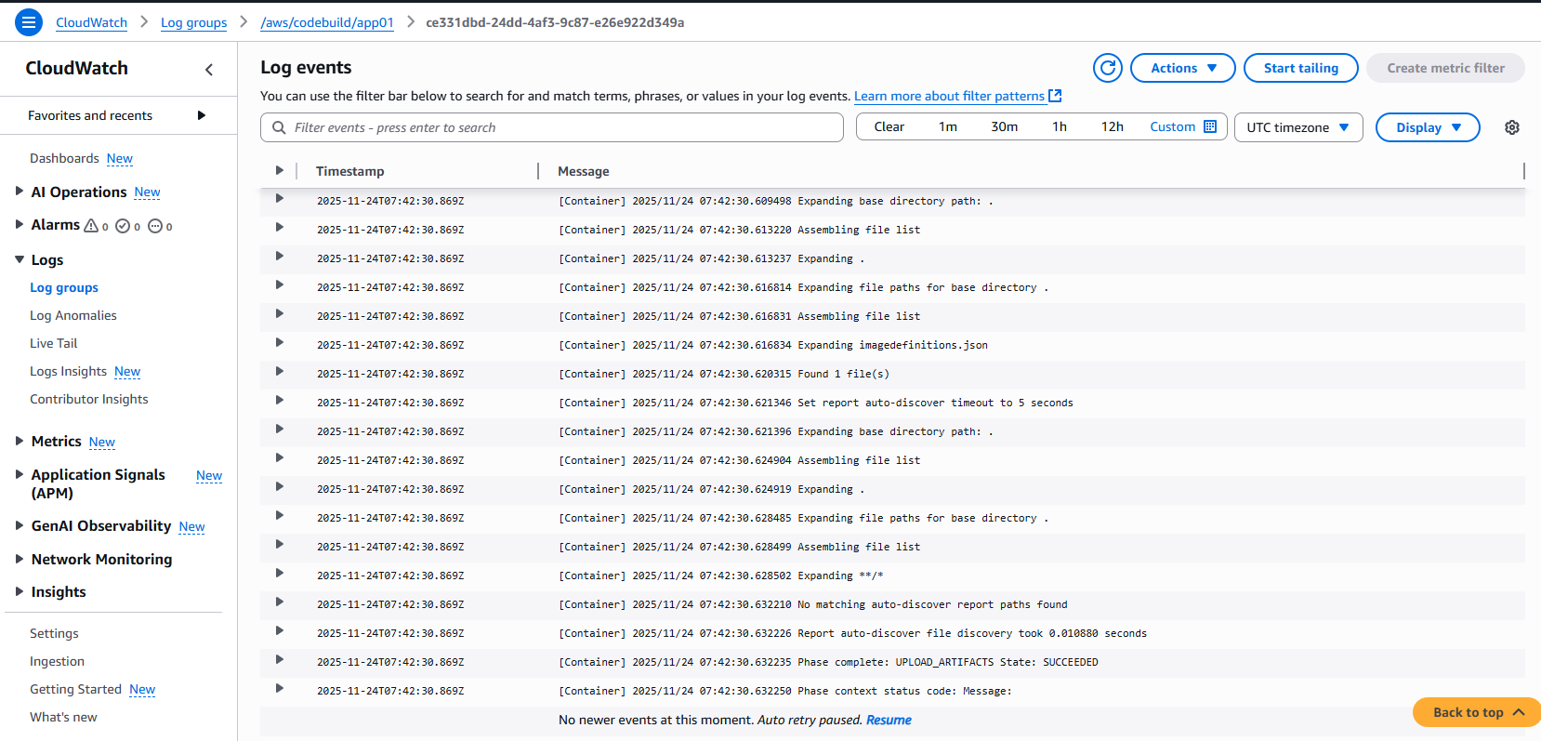
2.CodeDeploy Logs ==> Deployment steps.
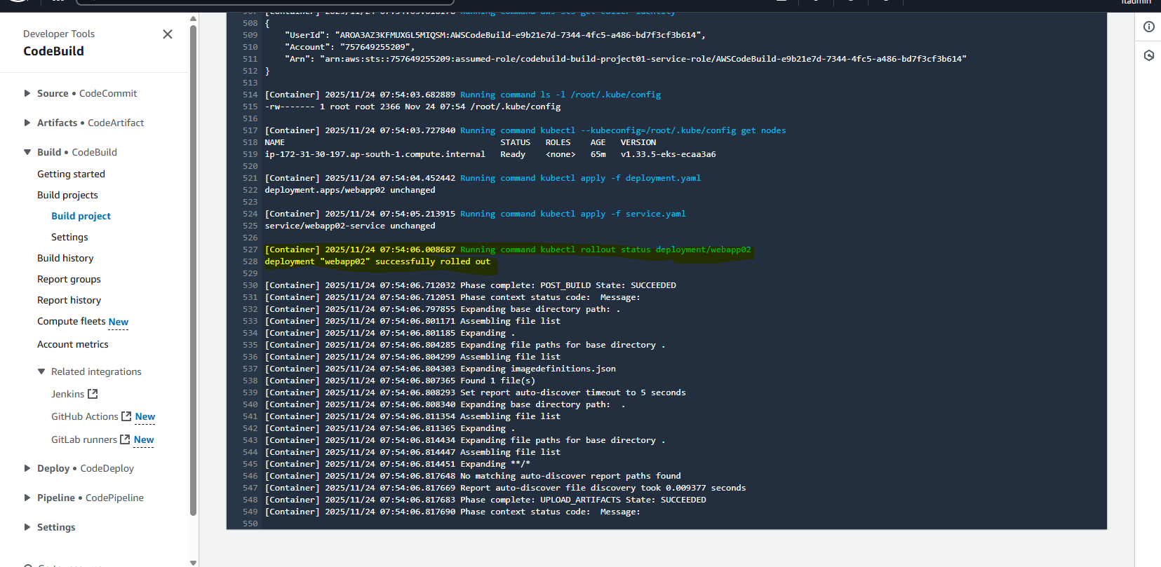
3.Application Logs ==> Via POD stdout(kubectl logs).

